**Supporting Information.** Feddern, M.L., G.W. Holtgireve, and E.J. Ward. 2021. Delayed trophic response of a marine predator to ocean condition and prey availability during the past century. Ecology.

**Section S1. Methods for compound specific stable isotope analysis**

Collagen samples have been analyzed for both CSIA and bulk δ15N which require 10 mg of purified collagen (100 mg of bone). Preliminary analyses were conducted to determine the highest rate of collagen return from bone sampled from different parts of the skull to minimize destruction. Samples were primarily taken from the internal occipital shelf to maintain external integrity. Bone was decalcified using 0.2 M HCl for 24-72 hours depending on bone thickness, followed by centrifugation and nanopure water rinse. Removal of humic acids was conducted using 0.125 M NaOH for 20 hours. Samples were washed to a neutral pH, then solubilized in 0.01N HCl. Once solubilized samples were blown down under N2 to prevent isotopic fractionation, and freeze dried. Freeze dried collagen was analyzed for bulk isotopic composition of nitrogen by the UW IsoLab (isolab.ess.washington.edu) using a coupled elemental analyzer-isotope ratio mass spectrometer following the standard protocols of the laboratory. C:N ratios were calculated from this data, which is a measure of the quality for carbon and nitrogen analyses of bone collagen for isotopic analysis. No observations were outside of the acceptable rang of 2.7-3.6; indicating there was no substantial loss of glycine or addition of nitrogen due to microbial processing from mortality, decay, curation, and analysis.

δ15N of eleven amino acids (alanine, glycine, proline, aspartic acid, leucine, isoleucine, valine, threonine, serine, glutamic acid, phenylalanine) were measured in the UW Facility for Compound-Specific Isotope Analysis of Environmental Samples. Samples were prepared following the procedures developed by Chikaraishi et al. (2007) and protocols by Rachel Jeffrey’s lab at University of Liverpool UK which are modifications of that published by Metges et al. (1996) and Popp et al. (2007). Briefly, proteins were hydrolyzed in 6N HCl and purified using a cation exchange column. 20 μL or norleucine was added as an internal standard. Amino acids were esterified using isopropanol acetyl chloride, and derivatized via acylation with 4:1 toluene: pivaloyl chloride. Samples were brought up in ethyl acetate and analyzed using a coupled gas chromatography-combustion-isotope ratio mass spectrometer system (GC-C-irMA; Thermo Scientific Trace GC + GC IsoLink coupled to a Delta V irMS) in continuous flow mode monitoring masses (m/z) 28 and 29. A 30 m x 0.32 mm x 0.50 μm Agilent Technologies DB-35 capillary column with 35% Phenyl and 65% polysiloxane stationary phase and moderate polarity (Chikaraishi et al. 2010) with an inlet temperature of 260 C, column flow of 2 ml/min and oven ramp of 9 ˚C min-1. For each run a 12 amino acid external standard with known isotopic composition was injected four times to condition the column followed by sample injections. Samples were injected in triplicate, with the 12 amino acid standard mixture injected every two samples (or six injections). A two-hour column oxidation was performed after 6 samples (25 injections) followed by a 30-minute backflush. δ15N was measured as:

For each machine run, a linear model was fit for each individual amino acid using the following equation:

Where *m* represents the slope of the precision drift, *t* represents the injection number since last column oxidation, and *Std* represents the δ15N of an individual amino acid, *aa*, for a standard observation. The data was then corrected using the following equations:

Where *Daa,t* is the difference between an observed standard δ15N (*Stdaa,t*) for a given amino acid (*aa*) at a given injection number (*t*) and the true δ15N for that standard. Then:

Where the drift value, *Daa,t*, is subtracted from the sample value for a given amino acid and a given injection to correct the observed sample values for precision drift since last column oxidation. Mean sample corrected values for the triplicate injections were used for all analyses and trophic position calculations. Norleucine had lower precision in standards compared to phenyalanine, therefore no correction using the internal standard was applied. Mean precision for a given *aa* standard was calculated using the standard deviation of the external standard injections for a given run after drift correction and taking a mean of each run's standard deviation (Table S13). Conditioning injections (first four standard injections) were omitted from this calculation.

**Section S2. Accounting for variability in trophic enrichment factors**

Trophic enrichment factors are variable based on animal diet (omnivory, carnivory, herbivory), pathways of nitrogen excretion, and trophic level (Nielsen et al. 2015, McMahon et al. 2015) with omnivory, carnivory and higher trophic levels demonstrating the lowest trophic enrichment for most amino acids. Trophic enrichment has ultimately been attributed to diet quality (similarity in tissues between consumer and prey) and mode of nitrogen excretions, although the relative impacts of each is difficult to discern, especially considering most controlled feeding studies include low-trophic level ammonia excretion but not high trophic level species (i.e., adult hake or salmon). In coastal Washington, most trophic transfers are between high diet quality, piscivorous fish (ammonia excretion) with a high-quality transfer between fish and harbor seal (urea excretion). Studies using multiple trophic enrichment factors based on the food web structure and consumption type produce more accurate trophic position estimations especially for higher level consumers (McMahon et al 2015, McMahon et al. 2016, McMahon et al. 2019).

We applied multiple trophic position calculation frameworks for harbor seals to determine the best approach (Tables S1 & S2) by identifying the percentage of data that fell within an ecologically realistic trophic position range for harbor seals. We also applied these approaches to herring, a known harbor seal prey species, with data from Germain et al. 2013. Based on known foraging patterns, we anticipate harbor seals have an average trophic position of 3.5 to 5 and herring will have an average trophic position of 2.5-2.9. Equation 2 produced the most accurate herring trophic position estimates for most amino acids, however valine produced an impossibly low estimate of trophic position. In contrast, equation 3 produced the most accurate results for most amino acids compared to harbor seals, but these estimates were still unrealistically low for some amino acids (proline, valine), which is common for CSIA (Table S1, McMahon et al. 2016). Additionally, this is not the most ecologically accurate parameterization, as it assumes all trophic transfers are of high prey quality, where there must be at least one herbivorous-low quality trophic transfer in the food web from phytoplankton to zooplankton (parameterization of equation 4, Table S1). It also assumes prey quality (carnivorous) and trophic level of the consumer is more important than nitrogen excretion pathway (urea versus ammonia) for some amino acids but not others. Seemingly, these assumptions impact trophic position estimates from individual trophic amino acids differently which will likely be an important consideration for future studies applying a multi-amino acid framework. It is possible that these reflect biases in conventional trophic position estimates (i.e., stomach content analysis) as proposed by McMahon (2015) or there may be biases in controlled feeding studies. For example, growth rate of individuals in controlled feeding studies may not accurately reflect those in natural ecosystems which may lead to overestimates in trophic enrichment if they are higher in natural systems compared to controlled feeding experiments. This may be plausible in the Washington food web as consumption of juvenile fish is common at multiple trophic levels, and juveniles presumably have higher growth rates than adults.

**Section S3. Identifying size and sex-based trends in harbor seal trophic position**

Only a subset of the samples included month of collection, sex, and length metadata and therefore separate month, length, and sex specific analyses were fit to the data to test whether they should be considered as predictors for the ocean condition and prey availability data. Standard linear models (equation S5) with: 1) sex as a factor, 2) length as a continuous covariate and 3) month as a continuous covariate were fit to both Salish Sea and coastal WA for each individual trophic amino acid. These models were used to test whether trophic position varies with length and sex, whether these trends are consistent between amino acids, and whether one year was an appropriate approximation for tissue turnover of bone collagen. The standard linear models took the following structure:

where *y* represents harbor seal trophic position calculated from phenylalanine and a trophic amino acid *i*, ***X*** is a matrix of bottom-up drivers for a given model, ***β*** is a vector of covariates (sex, length, month, location), and *a* is the intercept. There were no significant differences in trophic position between male and female harbor seals in either the Salish Sea (Figure S6A) or coastal Washington (Figure S6B); this relationship was consistent across amino acids. Similarly, trophic position did not change based on harbor seal length (Figure S5). Interestingly, the exception to this finding was trophic position calculated by proline, which showed a significant decline with size. Mean harbor seal trophic position calculated from proline for harbor seals ranging from 150 - 180 cm in standard was 0.6 lower than harbors seals that were less than 120 cm of standard length (Figure S5). Trophic position calculated from alanine, aspartic acid and valine also showed negative trends with size, although the trend was not statistically significant, while trophic position calculated from glutamic acid was positive but also not statistically significant. There was also no observed ‘seasonality’ in harbor seal trophic position (Figure S2) indicating 1-year physiological delay was a reasonable approximation for tissue turnover time of skull bone collagen.

Harbor seals in Washington do not have distinct trophic ecology based on adult size (Figure S5) or sex (Figure S6). Bjorkland et al. (2015) did not observe sex or size (weight) based differences in bulk 15N values in harbor seals in the San Juan Islands in the Salish Sea between 2007 and 2008. Our results agree with this finding and with similar studies of other Pacific pinniped species (Drago et al. 2009, Dehn et al. 2007). While both male and female harbor seals have a similar trophic position, it is possible sex and size-based differences in foraging strategies within a similar trophic position exist (Bjorkland et al. 2015, Wilson et al. 2014). Additionally, this study focused on adult harbor seals and changes in trophic position between juveniles, sub adults and adults are possible as indicated by pinniped studies (Zhao et al. 2004). Regardless, our results show long-term consistencies in the trophic niche exploited by both male and female harbor seals regardless of adult size in Washington.

**Section S4. Identifying temporal trends in harbor seal trophic position**

To understand any changes through time to harbor seal foraging ecology over the past 100 years that were not explained by the tested environmental and food web covariates (Tables S3 & S4), generalized additive models (GAMs) were fit the residuals for the best ocean condition-prey model with a smooth term by year and a k term of 5. These analyses (Figures S6 & S9) were compared to the raw time series of harbor seal trophic position data (Figure S7) to identify trends through time that are unexplained by the covariates included in this analysis.

Trends in harbor seal trophic position through time were different between the Salish Sea and coastal Washington (Figure S7). The time series of the glutamic acid trophic position in coastal Washington had a significant positive trend through time (Figure S7b) that increased from 1948-1968 and remained relatively constant following 1975. Trophic position calculated from alanine and proline showed similar trends, although the alanine trophic position trend was not statistically significant (Figure S7a). In contrast, harbor seal trophic position in the Salish Sea calculated from glutamic acid, alanine, aspartic acid, and proline has been relatively stable over the past century, but the trophic position calculated from valine showed a significant decline since 1968.

There were no trends through time for the model residuals for any amino acid after accounting for environmental (Figure S8) and food web (Figure S9) conditions at all three time lags. This indicates that prey availability and ocean conditions account for most temporal variation observed in the trophic position time series (Figure S7). However, valine was a notable exception, which demonstrated a decreasing trend through time in model residuals for all of the models with the most support.

**Section S5. Methods for Multivariate Autoregressive State-Space (MARSS) Model**

A MARSS model was fit to herring stock spawning biomass and harbor seal stock population size in order to get total population and total biomass estimates for these species for each year. Harbor seal datasets and herring biomass were collected by stock (n = 7 and n = 20, respectively) but did not have observations for every for every year (Figures S12 & S14). Two MARSS models were fit to the data, one for each species, to estimate population and biomass for each year for each for each stock (Figures S13 & S15). For both datasets process error (Q) assumed equal variance and covariance across stocks, and observation error (R) was assumed to be equal across stocks. U and x0 were both set to unequal, thus assuming they vary across stocks. Model states (Figures S13 & S15) were summed across years for total biomass (herring) and population size (harbor seals) estimates and used as covariates for prey availability models. Harbor seal data has not been collected since 2000 and we assumed the population has remained constant from 2000-2010.

**Section S6. Using multi-trophic amino acid analysis compared to only glutamic acid**

Mean harbor seal trophic position estimates were similar across trophic amino acids however some were more variable than others. The standard deviation of trophic position was higher for proline (4.6 ± 0.7, mean ± 1SD), and valine (3.7 ± 0.8) and included more ecologically unrealistic values compared to glutamic acid (4.5 ± 0.4) and alanine (3.9 ± 0.4). Trophic position calculated from aspartic acid (4.1 ± 1.0) had the highest standard deviation and also demonstrated a trend through time compared to other amino acid trophic position calculations (Figure S7).

Application of a multi-amino acid trophic position calculation 1) offered a more realistic parameterization of the trophic position equation, 2) improved model certainty and 3) produced similar covariate coefficients compared to a glutamic acid only parameterization (Table S6). Examination of the distribution of trophic position calculations for each individual trophic amino acid shows variability in accuracy and variance for single trophic amino acid calculations (Figures S3 & S4). For example, aspartic acid had a much wider variance compared to other amino acids (Figures S3 & S4) and also produced different trends through time (Figure S7).

It is likely differences in tissue turnover time between individual amino acids and phenylalanine contribute to the variance of the trophic position estimates derived from individual trophic amino acids. Downs et al. (2014) found phenylalanine takes 780 hours to reach 50% turnover in shrimp. This is comparable to glutamic acid, alanine, and valine which take 940, 642, and 942 hours respectively which are substantially lower than aspartic acid which requires 1530 hours. The discrepancy between tissue turnover times between aspartic acid and phenylalanine is likely the cause of the broad distribution for aspartic acid derived trophic position compared to other trophic amino acids, as aspartic acid is incorporating the nitrogen isotope signature over a substantially larger time period relative to phenylalanine and thus may incorporate more prey switching and/or changes in the isotopic signature of primary producers.

Addition of alanine to the glutamic acid only model resulted in the largest difference in model certainty. A glutamic acid – alanine model supported the same best models for both the environmental and prey models at all time lags. The combined tissue turnover of glutamic acid and alanine of shrimp (791 hours) is very similar to that of phenylalanine (780 hours) ensuring both the trophic and source amino acids were incorporated over a similar time scale (albeit the trophic amino acids were a wider time scale). Benefits of a multi-amino acid trophic position equation may not require four amino acids as previously suggested (Nielsen et al. 2015) but rather carefully selected trophic amino acids to ensure the trophic amino acids are incorporated over a similar time scale as the source amino acids. If tissue turnover times are unable to be approximated, utilizing four trophic amino acids or two source amino acids as suggested by Nielsen et al. (2015) would likely provide the same benefit as fewer, carefully selected amino acids based on tissue turnover times.

**Section S7 Tissue turnover time assumption validation**

Tissue turnover time of bone collagen in large mammals is not well studied due to the challenges of repeatedly measuring bone in a controlled feeding study. Hobson et al. (1992) found the half-life of carbon in bone collagen of Japanese quails (*Coturnix japonica*) is 170 days. A comparative study of the δ15N values in elephant seal bone and tooth dentin found the δ15N value in skull (maxilla and mandible) bone collagen was significantly correlated with the previous two years of tooth dentin (Riofrío-Lazo and Aurioles-Gamboa 2013). Another comparative study of northern fur seal (*Callorhinus ursinus*) and California sea lion (*Zalophus californianus*)young-of-year estimated that complete bone collagen turnover takes approximately 8 months (Newsome et al. 2006). Complete bone collagen turnover should be slower in adults than growing young-of-year. Altogether, this indicates that the δ15N values in skull bone collagen is time averaged over the past 1 – 2 years of the seals life.

To further test the assumption that stable isotope composition of bone collagen of adult harbor seals reflect the last year of the animals life, month was tested as a smoothed predictor with up to 12 knots for trophic position estimates using a generalized additive model (GAM). Support for a significant smoothing term or trend in the data would identify and seasonality in the data, which would be expected if tissue turnover time is consistently less than a year. There was no support for a smoothing effect by month in generalized additive models of δ15NPhe and δ13C values which would have indicated any seasonal variability in isotope composition and thus a turnover time of less than a year (p < 0.05; Appendix S1:Figure S2).

**Figure S1:** Temporal distribution of sampled harbor seal museum specimens in coastal Washington and the Salish Sea. Colors denotes time period specimens were collected.

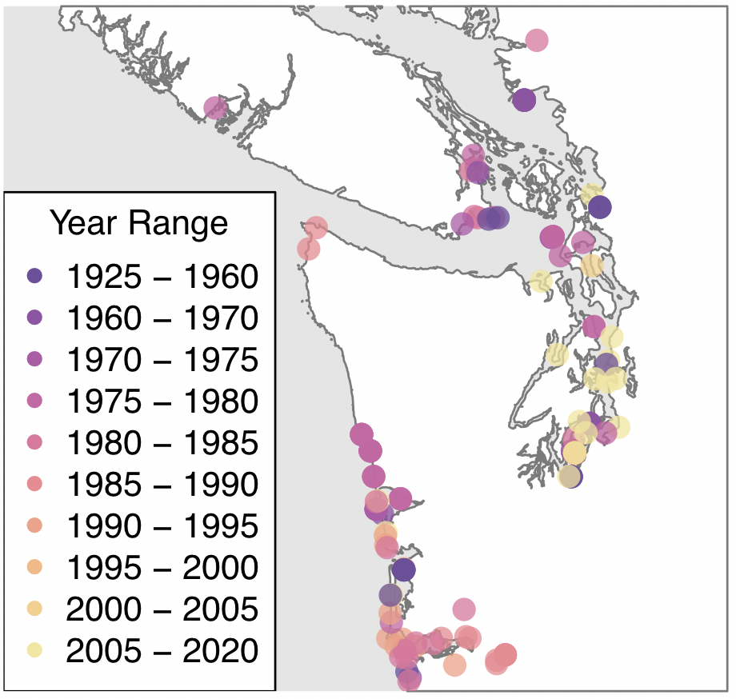

**Figure S2:** Analysis of seasonality of harbor seal trophic position for five different trophic amino acids (glutamic acid, alanine, aspartic acid, valine, and proline) calculated using the source amino acid phenylalanine and equation 2 (Table S2; Figure S4.2) with a weighted beta. Color corresponds to trophic amino acid, line shows the fit of a generalized additive model with a smoothed term by month (1 = January, 12 = December) and a k of 12. Smoothed terms were not significant.

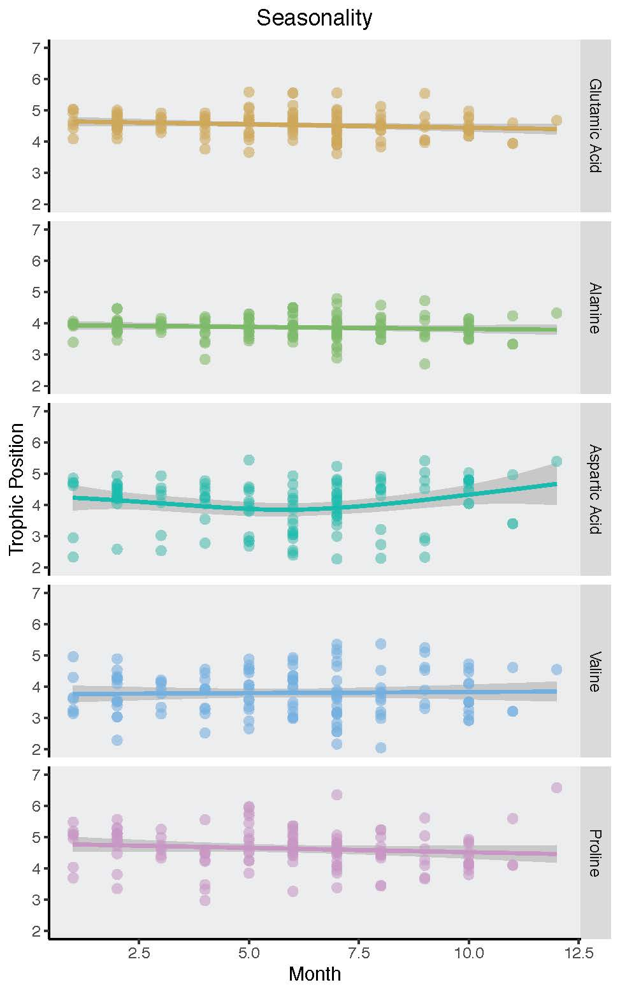

**Figure S3:** Distributions (density of probability, y-axis) of calculated trophic position (x-axis) for harbor seals in this study. Equations (1-4) refer to Table S1 and parameter values described in Table 1 of the main text. Colors correspond to trophic amino acids (*Tr*) and the grey box represents ecologically realistic trophic positions for harbor seals if they were to predate 1 trophic position above herring (trophic position of 2.5, minimum expected value) and one trophic position below killer whales (trophic position of 6, maximum). The value within the grey box corresponds to the percentage of observed trophic position values that fell within the ecologically realistic range.

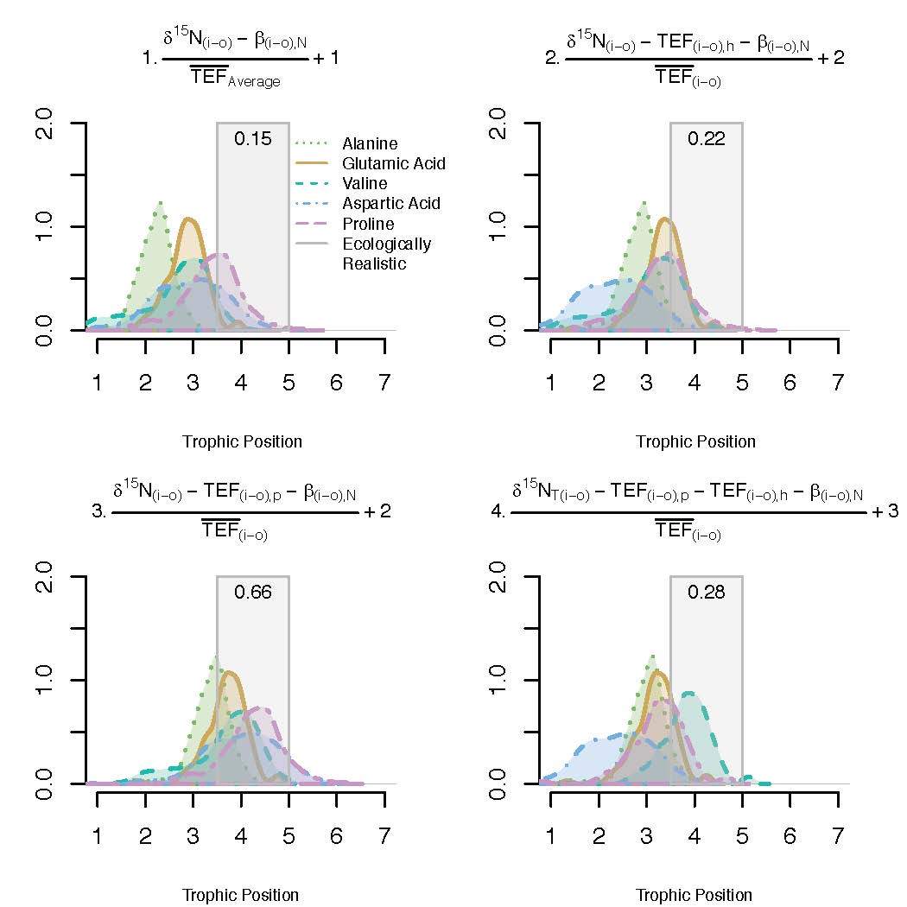

# **Figure S4:** Distributions (density of probability, y-axis) of calculated trophic position (x-axis) for harbor seals in this study applying equations (1-4) in Table S1 with β(i-o),NV instead of β(i-o),N as described in Table 1 of the main text.

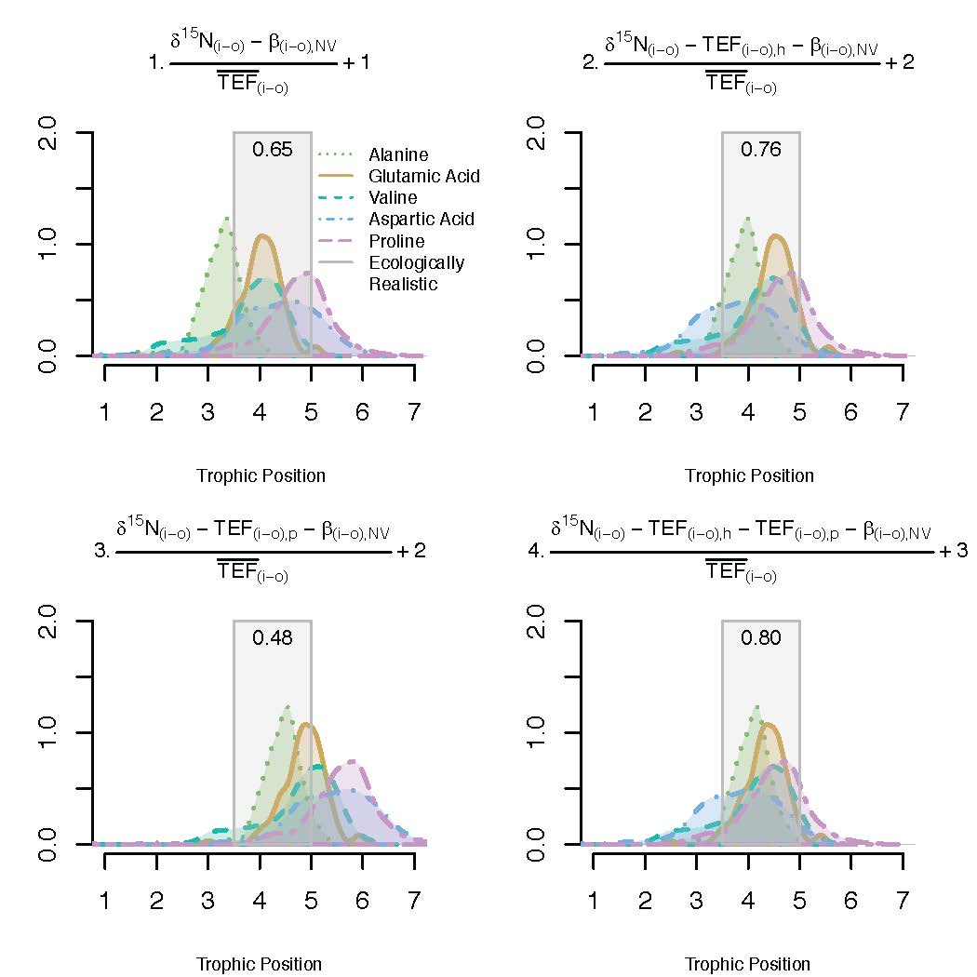

**Figure S5:**  Relationship between harbor seal size (standard length, cm) and trophic position calculated using five different trophic amino acids (glutamic acid, alanine, aspartic acid, valine, and proline). The line shows the fit of a generalized additive model with a smoothed term by year and a k of 6 and * denotes a significant smoothed term.

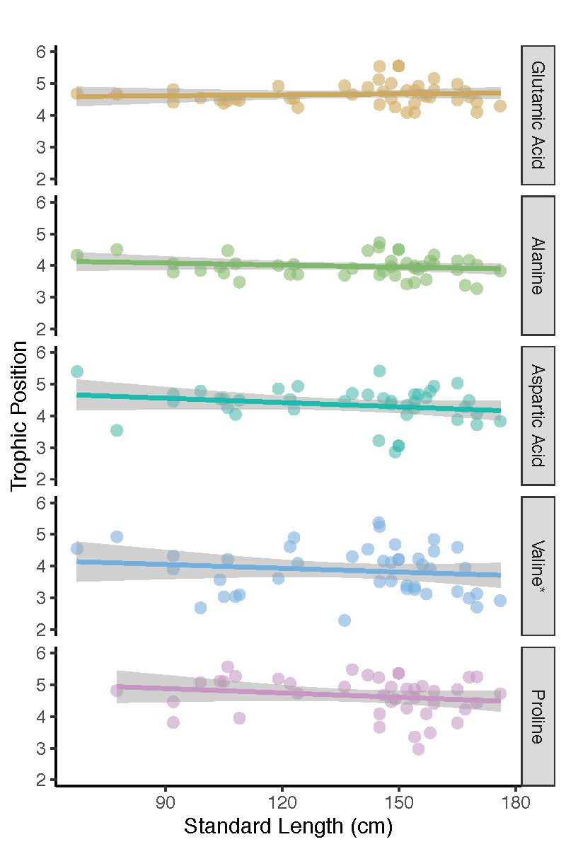**Figure S6**: Sex specific trophic position for male (M) and female (F) harbor seals pooled over the past century and calculated using five different trophic amino acids (glutamic acid, alanine, aspartic acid, valine, and proline) for a) Salish Sea and b) coastal Washington specimens.

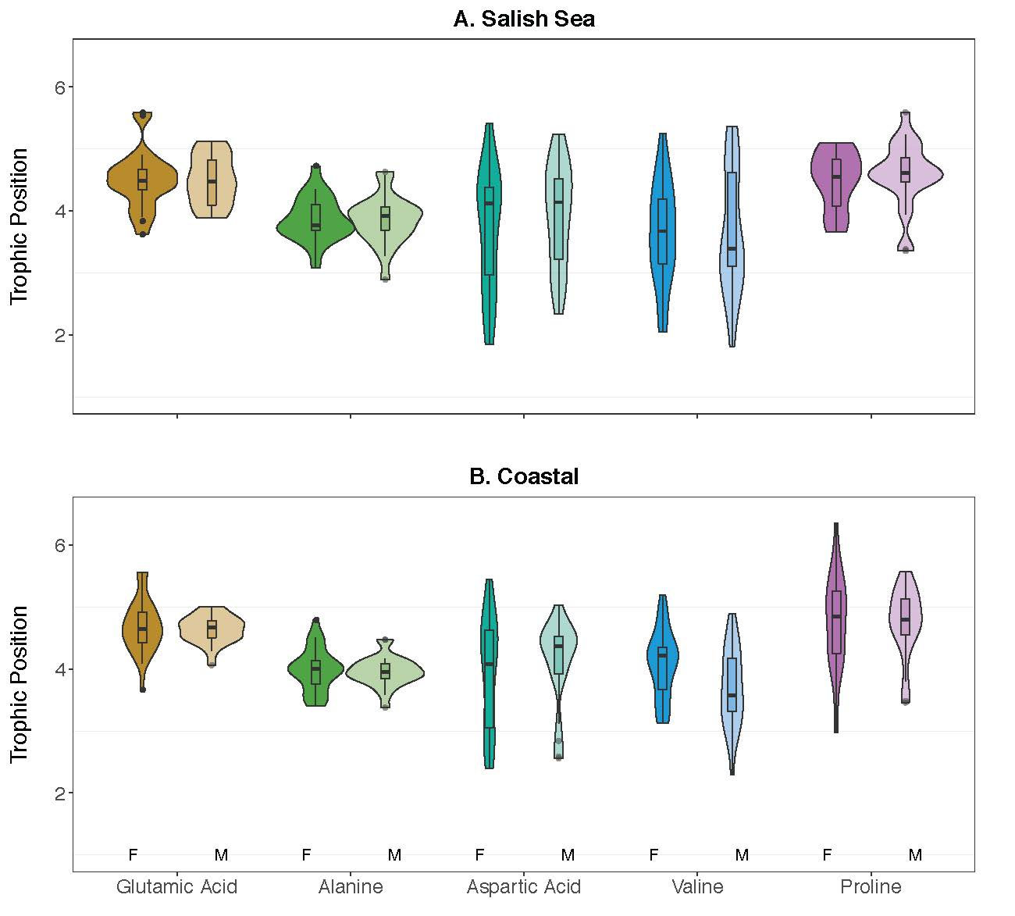

**Figure S7:** Time series of harbor seal trophic position in a) coastal Washington and b) the Salish Sea for five different trophic amino acids (glutamic acid, alanine, aspartic acid, valine, and proline) calculated using the source amino acid phenylalanine. Color corresponds to trophic amino acid, while line shows the fit of a generalized additive model with a smoothed term by year and a k of 6. * denotes a significant smoothed term.

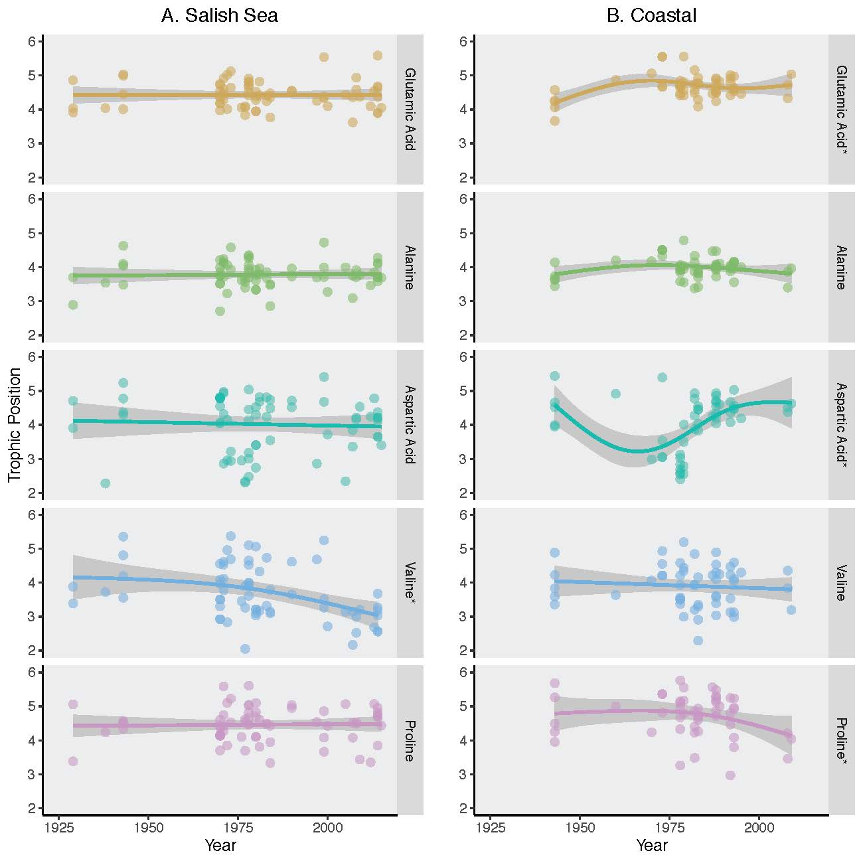

**Figure S8:** Time series of residuals by year for the three ocean condition models (physiological delay, 1-year ecological delay, 2-year ecological delay) with the most support for the four different trophic amino acids used in the models (glutamic acid, alanine, valine, and proline) with trophic position calculated using the source amino acid phenylalanine. Color corresponds to trophic amino acid, line shows the fit of a generalized additive model with a smoothed term by year and a k of 6. * denotes a significant smoothed term.

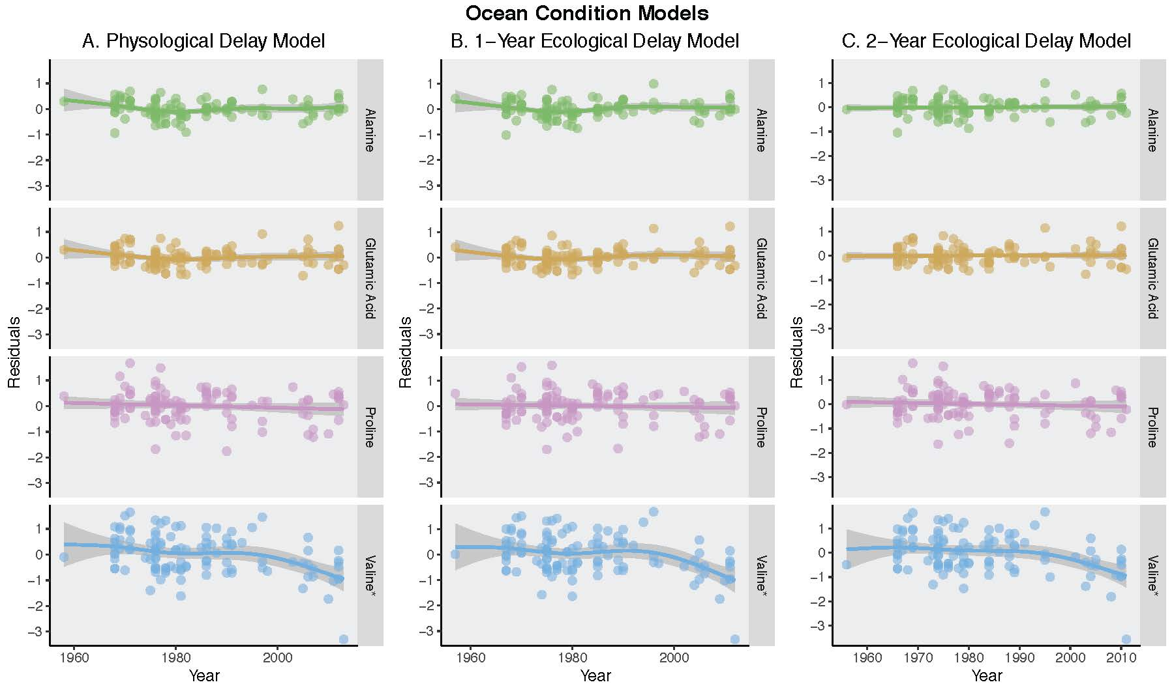

**Figure S9:** Time series of residuals by year for the three food web models (physiological delay, 1-year ecological delay, 2-year ecological delay) with the most support for the four different trophic amino acids used in the models (glutamic acid, alanine, valine, and proline) with trophic position calculated using the source amino acid phenylalanine. Color corresponds to trophic amino acid, line shows the fit of a generalized additive model with a smoothed term by year and a k of 6. * denotes a significant smoothed term.

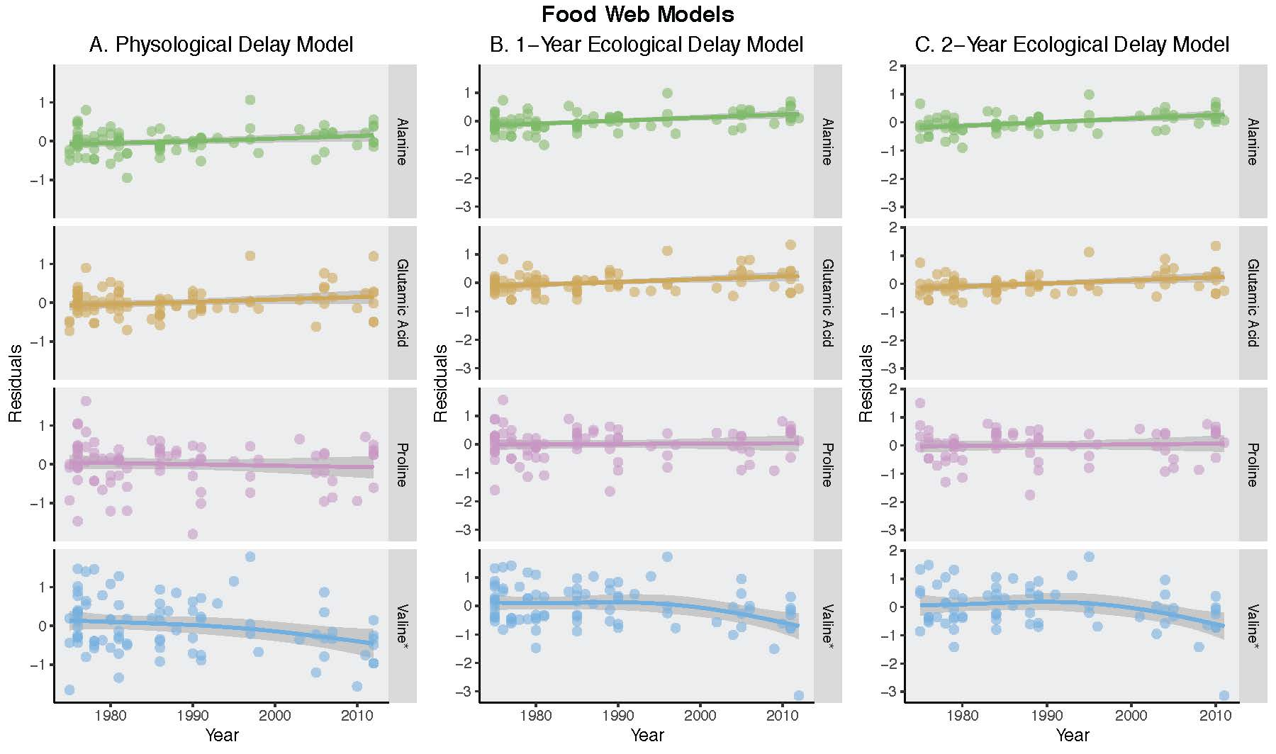

**Figure S10:** Residual plots for the physiological delay, 1-year ecological delay, and 2-year ecological delay ocean condition models with the most support.



**Figure S11:** Residual plots for the physiological delay, 1-year ecological delay, and 2-year ecological delay food web models with the most support.



**Figure S12:** Pacific herring spawning biomass by stock from Siple and Francis 2015.

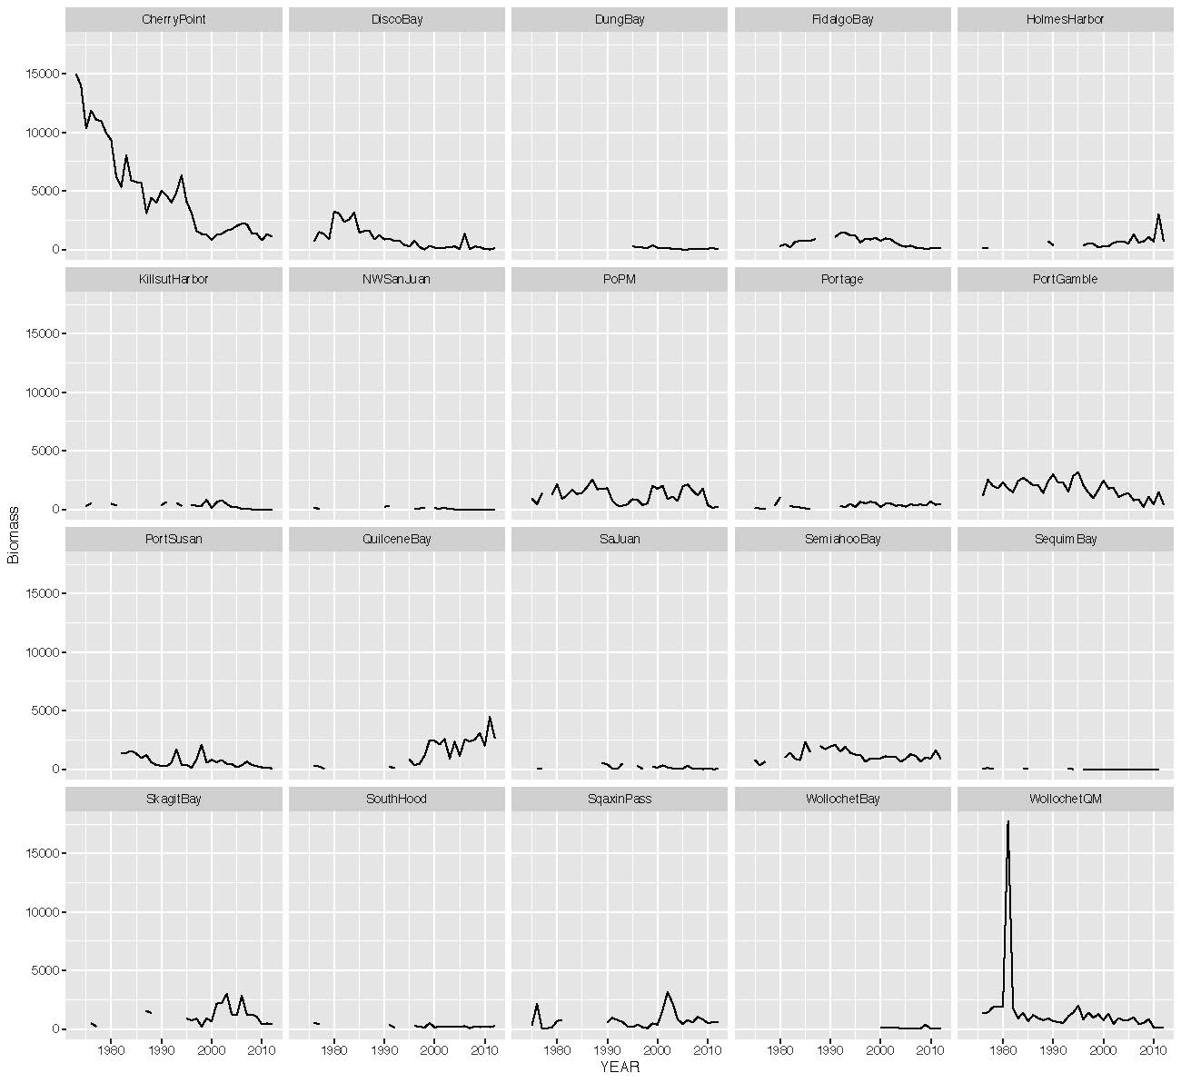

**Figure S13:** MARSS model (described in Appendix S3) for Pacific herring spawning biomass by stock.

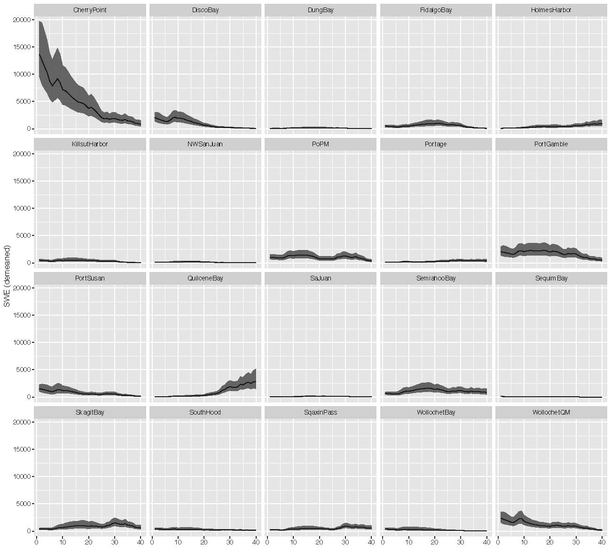

**Figure S14:** Harbor seal population estimates by stock from Jeffries et al. 2003.

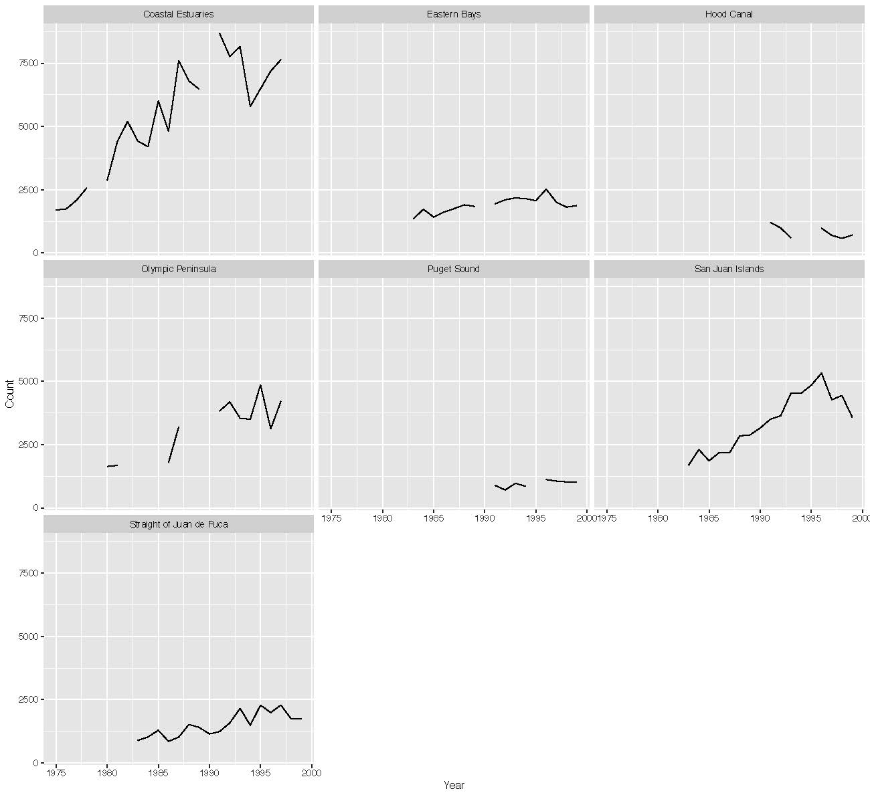

**Figure S15:** MARSS model (described in Appendix S3) for harbor seal population counts fit by stock.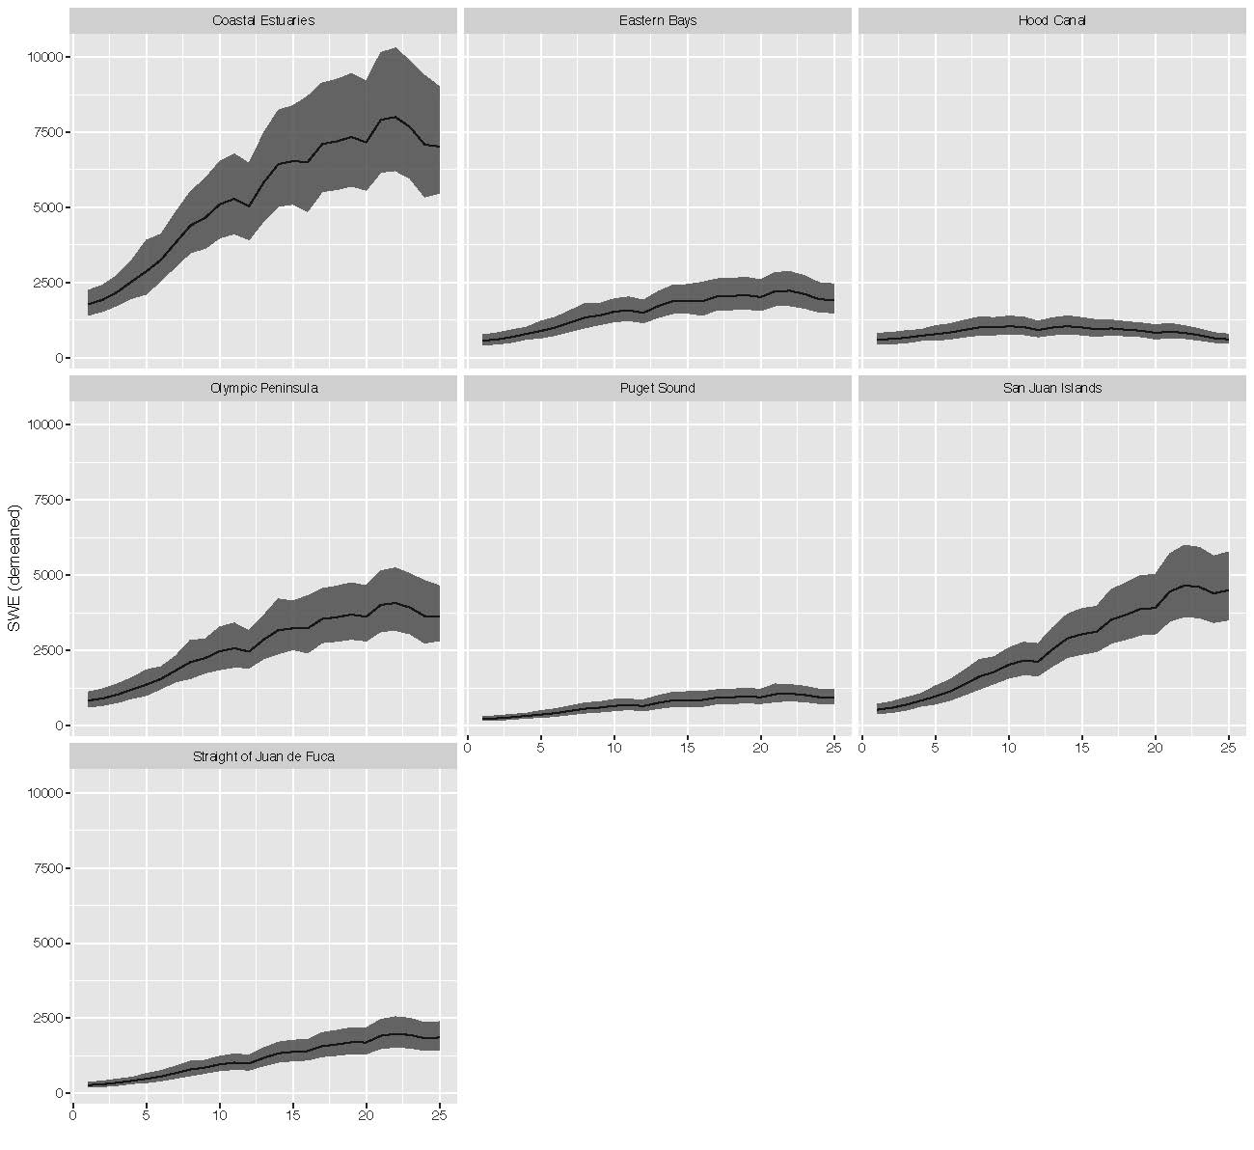

**Table S1**: Equations for single and multi-trophic enrichment factor parameterizations of trophic position and the associated assumptions for each parameterization using the values described in Table 1 in the main text. *i* refers to an individual trophic amino acid and *o* refers to a source amino acid, in this case phenylalanine. In addition to β(i-o), N (Figure S3) refers to β(i-o) for non-vascular plants, the same equations were used with β(i-o) NV (equation 6, Figure S4). Applying β(i-o) NV has the additional assumption that both vascular and nonvascular plants contribute to the coastal food web in which harbor seals forage and that the contributions of each can be calculated from bulk δ13C data (equations 2 & 3).

|  |  |
| --- | --- |
| Parameterization Assumptions | Equation |
| 1. Assumes that all trophic transfers are best represented by the average TDF in this system |  |
| 2. Includes harbor seal specific TDF (*TDF(i-o), h*) which assumes one trophic transfer is from high quality prey (and urea excretion) and assumes average TDF accurately represents all other trophic transfers |  |
| 3. Includes a TDF derived from basal food web consumers (zooplankton / herbivores; *TDF(i-o), p*) which assumes one trophic transfer is from low quality prey and assumes average TDF accurately represents all other trophic transfers |  |
| 4. Includes a TDF derived from basal food web consumers (zooplankton / herbivores; *TDF(i-o), p*) and a harbor seal specific TDF (*TDF(i-o), h*). This assumes one trophic transfer iis from low quality prey and a second is from high quality prey (and urea excretion). Assumes average TDF accurately represents all other trophic transfers |  |

**Table S2:** Trophic amino acid specific parameter values for *β* and trophic enrichment factors (*TEF*) to test parameterization of trophic position calculations using multiple TEFs and β values. The source amino acid (*o*) for all parameters was phenylalanine (Supplementary Material Appendix 1, Table S1, Figures S2 & S3). Values are mean ± SD.

|  |  |  |  |  |  |
| --- | --- | --- | --- | --- | --- |
| Trophic Amino Acid (*i*) | *β(i-o), N*  Nielsen et al. 2015 | *β(i-o), V*  Vander Zanden et al. 2013 | *β(i-o), NV*  This study | *TEF(i-o), j*  Germain et al. 2013 | Nielsen et al. 2015 |
| Glutamic acid (Glu) | 2.9 ± 2.0 | -8.7 ± 1.1 | -3.9 ± 1.2 | 3.4 ± 2.4 | 6.6 ± 1.7 |
| Alanine (Ala) | 2.8 ± 2.2 | -8.0 ± 1.0 | -3.6 ± 1.1 | 2.5 ± 2.9 | 6.8 ± 2.2 |
| Aspartic Acid (Asp) | 1.8 ± 2.9 | -7.3 ± 1.1 | -4.2 ± 1.0 | 3.5 ± 1.8 | 5.4 ± 1.8* |
| Valine (Val) | 3.4 ± 2.9 | -6.8 ± 1.0 | -2.6 ± 0.9 | 7.5 ± 3.7 | 4.6 ± 3.4 |
| Proline (Pro) | 2.7 ± 2.1 | -7.7 ± 1.2*  Not reported used average of other amino acids | -5.1 ± 1.1 | 5.5 ± 3.4 | 5.0 ± 1.8 |

**Table S3:** Covariates used to test ocean condition as a bottom-up driver of harbor seal trophic ecology. Total number of models tested = 35.

|  |  |  |  |
| --- | --- | --- | --- |
|  | Time Series Description | Length | Source |
| Discharge | Total discharge from the Columbia River at Dalles, WA during summer months of high discharge (May-Oct) from monthly U.S. Geological Survey discharge data. | 1879-2018 | Data Source: [USGS 14105700](https://waterdata.usgs.gov/nwis/uv?site_no=14105700) |
| Sea Surface Temperature (SST) | Average of monthly NOAA Extended Reconstructed SST for summer (Jul-Sep) in coastal Washington (48°N, 125°W). | 1854-2019 | Data Source: [NOAA ERSST V5](https://www.esrl.noaa.gov/psd/data/gridded/data.noaa.ersst.v5.html)  SST data was obtained from NOAA_ERSST_V5 data provided by the NOAA/OAR/ESRL PSD, Boulder, Colorado, USA, from their Web site at https://www.esrl.noaa.gov/psd/ (Huang et al. 2017). |
| Upwelling | Mean coastal upwelling index (CUI) coastal Washington (45°N, 125°W) using Bakun upwelling calculation based on Ekman's theory of mass transport due to wind stress, for spring (Apr-Jun) and summer (Jun-Sep). | 1946-2019. | Data Source: [NOAA ERD SWFSC](https://oceanview.pfeg.noaa.gov/products/upwelling/dnld) |
| North Pacific Gyre Oscillation | 2nd dominant mode of sea surface height variability in the northeast Pacific. Correlates with fluctuations in salinity nutrients and chlorophyll-a. | 1950-2019 | Data Source: Di Lorenzo et al. 2008. [NPGO](http://www.o3d.org/npgo/) |
| Multivariate ENSO Index | The extended Multivariate ENSO Index (MEI) uses Principle Component analysis on six variables: sea-level pressure, u and v component of the surface wind vector, sea surface temperature and cloudiness fraction in the tropical Pacific. | 1950-2019 | Data Source: NOAA/ESRL (https://psl.noaa.gov/enso/mei.ext/table.ext.html) via California Current Integrated Ecosystem Assessment [MEI](https://www.integratedecosystemassessment.noaa.gov/regions/california-current/cc-indicator-climate-ocean-drivers) |
| Pacific Decadal Oscillation | Same as eastern Bering Sea | 1900-2018 | Data Sources: [PDO](http://research.jisao.washington.edu/pdo/PDO.latest.txt); Zhang et al. 1997; Mantua et al 1997 |

**Table S4:** Covariates used to test prey availability as a bottom-up driver of harbor seal trophic ecology. Total number of models tested = 26.

|  |  |  |  |
| --- | --- | --- | --- |
|  | Time Series Description | Length | Source |
| Herring Biomass | Adult herring spawning biomass from egg deposition surveys for the estimated from Washington State Department of Fish and wildlife by Siple and Francis 2015.(MARSS output section S5, Figures S11 & S12) | 1973-2012 | Siple, M.C. and T.B. Francis. 2015. Population diversity in Pacific herring of the Puget Sound, USA. |
| Hake Biomass | Pacific Hake (whiting) relative spawning biomass in US and Canadian waters. | 1973-2012 | Berger et al. 2017. Table 8 total spawning biomass. |
| Chinook Salmon Spawners | Chinook salmon spawner summary data including all populations with a time series with data from at least 1973. Includes: Cedar River, Coweeman River, Elochoman River, Grays and Chinook Rivers, Green River, Kalama River, Lewis River, Lower Cowlitz River, Lower and Upper Sauk River, Lower and Upper Skagit River, McKenzie River, Mid-Hood Canal, Nisqually River, Puyallup River, Skokomish River, Skykomish River, Snoqualmie River, Suiattle River, Toutle River, Upper Gorge Tributaries, White River and White Salmon River. | 1973-2012 | Northwest Fisheries Science Center, 2020: SPS Abundance - Salmon spawner abundance data compilation and database management, [https://www.webapps.nwfsc.noaa.gov/apex/f?p=261:1:::NO::P1_ARCHIVE_NOTE_CHECK:1&cs=1A0A1845C9A3C7202FD5C2934C6FD9410#](https://www.webapps.nwfsc.noaa.gov/apex/f?p=261:1:::NO::P1_ARCHIVE_NOTE_CHECK:1&cs=1A0A1845C9A3C7202FD5C2934C6FD9410) |
| Chinook Salmon Smolt Production | Hatchery release data from the Regional Mark Information System and Wild Salmon Production data summarized by Chasco et al. 2017. Data was summed across both datasets for total juvenile salmon production. | 1973-2012 | RMIS: https://www.rmis.org//rmis_login.php?action=Login&system=cwt  Summarized: https://github.com/bchasco/COAST_WIDE |
| Harbor Seal Abundance | Harbor seal population estimates based on coastal estuary, eastern Bays, Hood Canal, Olympic Peninsula, Puget Sound, San Juan Islands, and the Strait of Juan de Fuca counts. (MARSS output section S5, Figures S13 & S14) | 1975-2012 | Jeffries, S., H. Huber, J. Calambokidis and J. Laake. 2003. Trends and status of harbor seals in Washington state: 1978-1999. The Journal of Wildlife Management 67: 207-218. |

**Table S5**: Full candidate model set (n = 35) for ocean condition modelling. The same candidate models were used for the physiological delay, 1-year ecological delay, and 2-year ecological delay models.

|  |
| --- |
| **Ocean Condition Candidate Models** |
| *Covariates* |
| 1. Null |
| 2. Location Only |
| 3. PDO, Location |
| 4. NPGO, Location |
| 5. MEI, Location |
| 6. Upwelling (Spring), Location |
| 7. NPGO, PDO, Location |
| 8. PDO, Upwelling (Spring), Location |
| 9. NPGO, Upwelling (Spring), Location |
| 10. MEI, Upwelling (Spring), Location |
| 11. SST (Summer), Location |
| 12. SST (Summer), PDO, Location |
| 13. SST (Summer), NPGO, Location |
| 14. SST (Summer), MEI, Location |
| 15. SST (Summer), Upwelling (Spring), Location |
| 16. SST (Summer), PDO, Upwelling (Spring), Location |
| 17. SST (Summer), NPGO, Upwelling (Spring), Location |
| 18. SST (Summer), MEI, Upwelling (Spring), Location |
| 19. Upwelling (Summer), Location |
| 20. Upwelling (Summer), PDO, Location |
| 21. Upwelling (Summer), NPGO, Location |
| 22. Upwelling (Summer), MEI, Location |
| 23. Upwelling (Summer), NPGO, Upwelling (Spring), Location |
| 24. Columbia Discharge (High), Location |
| 25. Columbia Discharge (High), PDO, Location |
| 26. Columbia Discharge (High), NPGO, Location |
| 27. Columbia Discharge (High), MEI, Location |
| 28. Upwelling (Spring), Location |
| 29. Columbia Discharge (High), PDO, Upwelling (Spring), Location |
| 30. Columbia Discharge High, NPGO, Upwelling (Spring), Location |
| 31. Columbia Discharge High, MEI, Upwelling (Spring), Location |
| 32. Columbia Discharge (High), SST (Summer), Location |
| 33. Columbia Discharge (High), Upwelling (Summer), Location |
| 34. SST (Summer), Upwelling (Summer), Location |
| 35. SST (Summer), Upwelling (Summer), Columbia Discharge (High), Location |

**Table S6**: Full candidate model set (n = 26) for prey availability modelling. The same candidate models were used for the physiological delay, 1-year ecological delay, and 2-year ecological delay models.

|  |
| --- |
| **Food Web Candidate Models** |
| *Covariates* |
| 1. Null |
| 2. Location Only |
| 3. Herring Spawning Biomass, Location |
| 4. Chinook Escapements, Location |
| 5. Chinook Smolt Production, Location |
| 6. Hake Spawning Biomass, Location |
| 7. Herring Spawning Biomass, Chinook Escapements, Location |
| 8. Herring Spawning Biomass, Hake Spawning Biomass, Location |
| 9. Herring Spawning Biomass, Chinook Smolt Production, Location |
| 10. Chinook Escapements, Hake Spawning Biomass, Location |
| 11. Chinook Escapements, Chinook Smolt Production, Location |
| 12. Chinook Smolt Production, Hake Spawning Biomass, Location |
| 13. Chinook Escapement, Chinook Smolt Production, Hake Spawning Biomass, Location |
| 14. Herring Spawning Biomass, Chinook Smolt Production, Hake Spawning Biomass, Location |
| 15. Chinook Escapements, Chinook Smolt Production, Herring Spawning Biomass, Location |
| 16. Herring Spawning Biomass, Hake Spawning Biomass, Chinook Escapements, Location |
| 17. Harbor Seal Abundance, Location |
| 18. Harbor Seal Abundance, Herring Spawning Biomass, Location |
| 19. Harbor Seal Abundance, Chinook Escapements, Location |
| 20. Harbor Seal Abundance, Chinook Smolt Production, Location |
| 21. Harbor seal Abundance, Hake Spawning biomass, Location |
| 22. Harbor Seal Abundance, Herring biomass, Chinook Escapements, Location |
| 23. Harbor Seal Abundance, Herring Spawning Biomass, Hake Spawning Biomass, Location |
| 24. Harbor Seal Abundance, Herring Spawning Biomass, Chinook Smolt Production, Location |
| 25. Harbor Seal Abundance, Chinook Escapements, Hake Spawning Biomass, Location |
| 26. Harbor Seal Abundance, Chinook Smolt Production, Hake Spawning Biomass, Location |
|  |

|  |  |  |  |  |  |  |  |  |  |  |  |  |  |  |  |  |  |  |  |  |  |  |  |  |  |  |  |  |  |  |  |  |  |  |  |  |
| --- | --- | --- | --- | --- | --- | --- | --- | --- | --- | --- | --- | --- | --- | --- | --- | --- | --- | --- | --- | --- | --- | --- | --- | --- | --- | --- | --- | --- | --- | --- | --- | --- | --- | --- | --- | --- |
| **Table S7**: Top ten ocean condition models with the most support (lowest AICC) with a physiological delay applied.   |  |  |  | | --- | --- | --- | | **Physiological Delay Top 10 Models (ocean condition)** | | | | *Covariates* | *AICc* | *delta AICc* | | 23. Upwelling (Summer), NPGO, Upwelling (Spring), Location | 742.75 | 0 | | 35. SST (Summer), Upwelling (Summer), Columbia Discharge (High), Location | 743.39 | 0.63 | | 33. Columbia Discharge (High), Upwelling (Summer), Location | 744.12 | 1.36 | | 19. Upwelling (Summer), Location | 744.3 | 1.55 | | 34. SST (Summer), Upwelling (Summer), Location | 744.7 | 1.95 | | 21. Upwelling (Summer), NPGO, Location | 745.25 | 2.5 | | 22. Upwelling (Summer), MEI, Location | 745.55 | 2.8 | | 20. Upwelling (Summer), PDO, Location | 746.11 | 3.36 | | 26. Columbia Discharge (High), NPGO, Location | 754.16 | 11.41 | | 30. Columbia Discharge High, NPGO, Upwelling (Spring), Location | 754.71 | 11.96 | |

|  |  |  |  |  |  |  |  |  |  |  |  |  |  |  |  |  |  |  |  |  |  |  |  |  |  |  |  |  |  |  |  |  |  |  |  |  |  |  |  |
| --- | --- | --- | --- | --- | --- | --- | --- | --- | --- | --- | --- | --- | --- | --- | --- | --- | --- | --- | --- | --- | --- | --- | --- | --- | --- | --- | --- | --- | --- | --- | --- | --- | --- | --- | --- | --- | --- | --- | --- |
| **Table S8**: Top ten ocean condition models with the most support (lowest AICC) with a 1-year ecological delay applied.   |  |  |  | | --- | --- | --- | | **1-Year Ecological Delay Top 10 Models (ocean condition)** | | | | *Covariates* | *AICc* | *delta AICc* | | 15. SST (Summer), Upwelling (Spring), Location | 734.84 | 0 | | 16. SST (Summer), PDO, Upwelling (Spring), Location | 736.55 | 1.7 | | 18. SST (Summer), MEI, Upwelling (Spring), Location | 736.65 | 1.81 | | 17. SST (Summer), NPGO, Upwelling (Spring), Location | 736.8 | 1.95 | | 14. SST (Summer), MEI, Location | 738.91 | 4.07 | | 11. SST (Summer), Location | 740.21 | 5.37 | | 32. Columbia Discharge (High), SST (Summer), Location | 741.3 | 6.46 | | 12. SST (Summer), PDO, Location | 741.34 | 6.49 | | 34. SST (Summer), Upwelling (Summer), Location | 741.99 | 7.15 | | 13. SST (Summer), NPGO, Location | 742.04 | 7.2 | |  | | | |

|  |  |  |  |  |  |  |  |  |  |  |  |  |  |  |  |  |  |  |  |  |  |  |  |  |  |  |  |  |  |  |  |  |  |  |  |  |
| --- | --- | --- | --- | --- | --- | --- | --- | --- | --- | --- | --- | --- | --- | --- | --- | --- | --- | --- | --- | --- | --- | --- | --- | --- | --- | --- | --- | --- | --- | --- | --- | --- | --- | --- | --- | --- |
| **Table S9**: Top ten ocean condition models with the most support (lowest AICC) with a 2-year ecological delay applied.   |  |  |  | | --- | --- | --- | | **2-Year Ecological Delay Top 10 Models (ocean condition)** | | | | *Covariates* | *AICc* | *delta AICc* | | 24. Columbia Discharge (High), Location | 742.09 | 0 | | 33. Columbia Discharge (High), Upwelling (Summer), Location | 742.83 | 0.74 | | 26. Columbia Discharge (High), NPGO, Location | 743.06 | 0.97 | | 25. Columbia Discharge (High), PDO, Location | 743.54 | 1.45 | | 28. Upwelling (Spring), Location | 743.86 | 1.77 | | 27. Columbia Discharge (High), MEI, Location | 744.04 | 1.95 | | 32. Columbia Discharge (High), SST (Summer), Location | 744.07 | 1.98 | | 35. SST (Summer), Upwelling (Summer), Columbia Discharge (High), Location | 744.48 | 2.38 | | 29. Columbia Discharge (High), PDO, Upwelling (Spring), Location | 744.56 | 2.47 | | 30. Columbia Discharge High, NPGO, Upwelling (Spring), Location | 745.06 | 2.97 | |

**Table S10**: Top ten prey availability models with the most support (lowest AICC) with a physiological delay applied.

|  |  |  |
| --- | --- | --- |
| **Physiological Delay Top 10 Models (Prey Availability)** | | |
| *Covariates* | *AICc* | *delta AICc* |
| 14. Herring Spawning Biomass, Chinook Smolt Production, Hake Spawning Biomass, Location | 547.29 | 0 |
| 12. Chinook Smolt Production, Hake Spawning Biomass, Location | 547.58 | 0.29 |
| 26. Harbor Seal Abundance, Chinook Smolt Production, Hake Spawning Biomass, Location | 549.48 | 2.2 |
| 13. Chinook Escapement, Chinook Smolt Production, Hake Spawning Biomass, Location | 549.5 | 2.21 |
| 23. Harbor Seal Abundance, Herring Spawning Biomass, Hake Spawning Biomass, Location | 549.54 | 2.25 |
| 6. Hake Spawning Biomass, Location | 549.55 | 2.27 |
| 21. Harbor seal Abundance, Hake Spawning iomass, Location | 551.18 | 3.89 |
| 10. Chinook Escapements, Hake Spawning Biomass, Location | 551.46 | 4.18 |
| 5. Chinook Smolts Production, Location | 552.72 | 5.43 |
| 16. Herring Spawning Biomass, Hake Spawning Biomass, Chinook Escapements, Location | 552.97 | 5.69 |

**Table S11**: Top ten prey availability models with the most support (lowest AICC) with a 1-year ecological applied.

|  |  |  |
| --- | --- | --- |
| **1-Year Ecological Top 10 Models (Prey Availability)** | | |
| *Covariates* | *AICc* | *delta AICc* |
| 13. Chinook Escapement, Chinook Smolt Production, Hake Spawning Biomass, Location | 554.76 | 0 |
| 12. Chinook Smolt Production, Hake Spawning Biomass, Location | 555.28 | 0.53 |
| 11. Chinook Escapments, Chinook Smolt Production, Location | 555.56 | 0.8 |
| 14. Herring Spawning Biomass, Chinook Smolt Production, Hake Spawning Biomass, Location | 555.91 | 1.15 |
| 26. Harbor Seal Abundance, Chinook Smolt Production, Hake Spawning Biomass, Location | 556.78 | 2.03 |
| 5. Chinook Smolts Production, Location | 557.22 | 2.47 |
| 15. Chinook Escapements, Chinook Smolt Production, Herring Spawning Biomass, Location | 557.5 | 2.74 |
| 20. Harbor Seal Abundance, Chinook Smolt Production, Location | 559.09 | 4.33 |
| 9. Herring Spawning Biomass, Chinook Smolt Production, Location | 559.22 | 4.46 |
| 24. Harbor Seal Abundance, Herring Spawning Biomass, Chinook Smolt Production, Location | 560.99 | 6.23 |

**Table S12**: Top ten prey availability models with the most support (lowest AICC) with a 2-year ecological delay applied.

|  |  |  |
| --- | --- | --- |
| **2-Year Ecological Top 10 Models (Prey Availability)** | | |
| *Covariates* | *AICc* | *delta AICc* |
| 11. Chinook Escapements, Chinook Smolt Production, Location | 480.69 | 0 |
| 10. Chinook Escapements, Hake Spawning Biomass, Location | 481.41 | 0.72 |
| 7. Herring Spawning Biomass, Chinook Escapements, Location | 484.2 | 3.51 |
| 4. Chinook Escapements, Location | 484.9 | 4.21 |
| 12. Chinook Smolt Production, Hake Spawning Biomass, Location | 485.17 | 4.48 |
| 5. Chinook Smolts Production, Location | 486.5 | 5.81 |
| 6. Hake Spawning Biomass, Location | 486.56 | 5.87 |
| 19. Harbor Seal Abundance, Chinook Escapements, Location | 486.74 | 6.05 |
| 9. Herring Spawning Biomass, Chinook Smolt Production, Location | 487.91 | 7.22 |
| 1. Null | 488.12 | 7.43 |

|  |  |
| --- | --- |
| Amino Acid | Mean Precision |
| Phenylalanine | 0.34 |
| Glutamic Acid | 0.56 |
| Alanine | 0.46 |
| Proline | 0.48 |
| Valine | 0.38 |
| Aspartic Acid | 0.83 |
| Norleucine | 0.40 |

**Table S13:** Mean standard precision for amino acids calculated as the average standard deviation of standard triplicate injections.

**Table S14:** Pearson correlation coefficients for harbor seal trophic position calculated from five trophic amino acids.

|  |  |  |  |  |  |
| --- | --- | --- | --- | --- | --- |
| Trophic Amino Acid | Glutamic acid (Glu) | Alanine (Ala) | Aspartic Acid (Asp) | Proline (Pro) | Valine (Val) |
| Glutamic acid (Glu) | **-** |  |  |  |  |
| Alanine (Ala) | 0.79 | **-** |  |  |  |
| Aspartic Acid (Asp) | 0.25 | 0.29 | **-** |  |  |
| Proline (Pro) | 0.46 | 0.61 | 0.17 | **-** |  |
| Valine (Val) | 0.58 | 0.61 | 0.18 | 0.39 | **-** |

**Table S15:** Covariates included in the best models using standard linear models and only glutamic acid to calculate trophic position. Supported models is the number of models with delta AIC < 2.

|  |  |  |  |
| --- | --- | --- | --- |
| Model | Covariates | Supported Models | Comparison to hierarchical models |
| *Ocean Condition Models* | | | |
| Physiological Delay | Summer upwelling, Columbia River discharge | 14 | Summer upwelling was included in best model and 6 others |
| 1-year ecological delay | Sea surface temperature, spring upwelling | 3 | Sea surface temperature was included in all supported models |
| 2-year ecological delay | Summer upwelling, MEI | 6 | Columbia River discharge was included in one supported glutamic acid only model |
| *Food Web Model* | | | |
| Physiological Delay | Location | 2 | Best hierarchical model (herring spawning biomass) was included in one supported glutamic acid only models |
| 1-year ecological delay | Chinook smolts | 3 | Hake spawning biomass was not included in the supported models |
| 2-year ecological delay | Location | 6 | Chinook smolt production was included in 2 supported models |

**Table S16:** Data summary showing mean trophic position calculated from glutamic acid (trophic) and phenylalanine (source), number of samples (n), and standard deviation (sd) for each year. Standard deviation of trophic position was calculated using the standard deviations for TEFs and *β* (Appendix S1:Table S2) and the analytical error for glutamic acid and phenylalanine (Appendix S1:Table S13) following the methods of Blum et al. 2013.

|  |  |  |  |
| --- | --- | --- | --- |
|  | | | |
| *Year* | *mean* | *SD* | *n* |
| 1928 | 4.3 | 0.2 | 3 |
| 1937 | 4.0 | 0.3 | 1 |
| 1942 | 4.4 | 0.1 | 9 |
| 1959 | 4.9 | 0.4 | 1 |
| 1969 | 4.5 | 0.1 | 9 |
| 1970 | 4.6 | 0.2 | 4 |
| 1971 | 4.5 | 0.3 | 2 |
| 1972 | 5.0 | 0.2 | 6 |
| 1975 | 4.1 | 0.3 | 1 |
| 1976 | 4.0 | 0.2 | 3 |
| 1977 | 4.7 | 0.1 | 14 |
| 1978 | 4.8 | 0.2 | 4 |
| 1979 | 4.2 | 0.1 | 5 |
| 1980 | 4.6 | 0.3 | 2 |
| 1981 | 4.7 | 0.2 | 4 |
| 1982 | 4.5 | 0.1 | 7 |
| 1983 | 4.2 | 0.2 | 3 |
| 1986 | 4.5 | 0.4 | 1 |
| 1987 | 4.6 | 0.1 | 8 |
| 1988 | 4.8 | 0.4 | 1 |
| 1989 | 4.5 | 0.3 | 2 |
| 1991 | 4.8 | 0.2 | 4 |
| 1992 | 4.7 | 0.2 | 5 |
| 1994 | 4.5 | 0.4 | 1 |
| 1996 | 4.3 | 0.3 | 1 |
| 1998 | 4.8 | 0.3 | 3 |
| 1999 | 4.1 | 0.3 | 1 |
| 2004 | 4.4 | 0.4 | 1 |
| 2006 | 4.0 | 0.2 | 2 |
| 2007 | 4.6 | 0.2 | 4 |
| 2008 | 4.7 | 0.3 | 2 |
| 2011 | 4.1 | 0.3 | 1 |
| 2012 | 4.5 | 0.4 | 1 |
| 2013 | 4.5 | 0.2 | 6 |
| 2014 | 4.0 | 0.3 | 1 |
|  |  |  |  |

**References**

Blum J.D., Popp B.N., Drazen J.C., Choy C.A., Johnson M.W. 2013. Methylmercury production below the mixed layer in the North Pacific Ocean. *Nature Geoscience* **6**, 879-884.

Bjorkland R.H., Pearson S.F., Jeffries S.J., Lance M.M., Acevedo-Guitiérrez A., Ward E.J. 2015. Stable isotope mixing models elucidate sex and size effects on the diet of a generalist marine predator. *Marine Ecology Progress Series* **526**, 213-225.

Chikaraishi Y., Kashiyama, Ogawa N.O., Kitazato H., Ohkoushi N. (2007). Metabolic control of nitrogen isotope composition of amino acids in macroalgae and gastropods: implications for aquatic food web studies. *Marine Ecology Progress Series* **342**, 85-90.

Chikaraishi Y., Takano Y., Ogawa N.O., Ohkouchi N. (2010). Instrumental optimization of

compound-specific nitrogen isotope analysis of amino acids by gas

chromatography/combustion/isotope ratio mass spectrometry. In: Tayasu I., Ohkouchi N.

Keisuke K. (Eds.) Earth, Life, and Isotopes (pp. 367- 386). Kyoto University Press.

Choi B, Sun-Yong H., Lee J.S., Chikaraishi Y., Ohkouchi N., Shin K. 2017. Trophic interaction among organisms in a seagrass meadow ecosystem as revealed by bulk δ13C and amino acid δ15N analyses. *Limnology and Oceanography* **62**, 1426-1435.

Dehn L.A., Sheffield G.G., Follmann E.H., Duffy L.K., Thomas D.L., O’Hara T.M. 2007. Feeding ecology of phocid seals and some walrus in the Alaskan and Canadian Arctic as determined by stomach contents and stable isotope analysis.

Downs E.E., Popp B.N., Holl C.M. 2014. Nitrogen isotope fractionation and amino acid turnover rates in the Pacific white shrimp *Litopenaeous vannamei*. *Marine Ecology Progress Series* 516: 239-250.

Drago M., Cardona L., Crespo E.A., Aguilar A. 2009. Ontogenic dietary changes in South American sea lions. *Journal of Zoology* **279**, 251-261.

Feddern M.L., Holtgrieve G.W., Ward E.J. 2021. Stable isotope signatures in archival pinniped bone link food web-assimilated carbon and nitrogen to a century of environmental change. *Global Change Biology*

Germain L.R., Koch P.L., Harvey J., McCarthy M.D. (2013). Nitrogen isotope fractionation in amino acids from harbor seals: implicatios for compound-specific trophic position calculations. *Marine Ecology Progress Series* **482**, 265-277.

Howe E.R., Simenstad C.A. (2015). Using stable isotopes to discern mechanisms of connectivity in estuarine detritus-based food webs. *Marine Ecology Progress Series* **518**: 13-29.

Lance, M. M., W. Chang, S. J. Jeffries, S. F. Pearson, and A. Acevedo-Gutiérrez. 2012. Harbor seal diet in northern Puget Sound: implications for the recovery of depressed fish stocks. Marine Ecology Progress Series 464: 257-271.

McMahon K.W., Thorrold S.R., Elsdon T.S., McCarthy M.D. 2015. Trophic discrimination of nitrogen stable isotopes in amio acids caries with diet quality in a marine fish. *Limnology and Oceanography* 60 (3): 1076-1087.

McMahon K.W., McCarthy M.D. 2016. Embracing variability in amino acid δ15N fractionation: mechanisms, implication, and applications for trophic ecology. *Ecosphere* **7**, e01511.

McMahon K.W., Michelson C.I., Hart T., McCarthy M.D., Patterson W.P., Polito M.J. (2019). Divergent trophic responses of sympatric penguin species to historic anthropogenic exploitation and recent climate change. *PNAS* **116**, 25721-25727.

Metges C.C., Petzke K. (1996). Gas chromatography/combustion/isotope ratio mass spectromic

comparison of N-Acetyl- and N-Pivaloyl amino acid esters to measure 15N isotopic

abundances in physiological samples: a pilot study on amino acid synthesis in the upper

gastro-intestinal tract of minipigs. Journal of Mass Spectrometry 31, 367-376.

Nielsen J.M., Popp B.N., Winder M. 2015. Meta-analysis of amino acid stable nitrogen isotope ratios for estimating trophic position in marine organisms. *Oecologia* **178**, 631-642.

Popp B.N., Graham B.S., Olson R.J., Hannides C.C.S., Lott M.J., López-Ibarra G.A., Galván-

Magaña F., Fry B. (2007). Insights into the trophic ecology of yellowfin tuna, Thunnes

albacores, from compound-specific nitrogen isotope analysis of proteinaceous amino

acids. Terrestrial Ecology 1, 173-190.

Shelton A.O., Francis T.B., Feist B.E., Williams G.D., Lindquist A., Levin P.S. 2017. Forty years of seagrass population stability and resilience in an urbanizing estuary. *Journal of Ecology* **105**, 458-470.

Vander Zanden H.B., Arthur K.E., Bolten A.B., Popp B.N., Lagueux C.J., Harrison E., Campbell C.L., Bjorndal K.A. 2013. Trophic ecology of a green turtle breeding population. *Marine Ecology Progress Series* **476**, 237-249.

Wilson K., Lance M., Jeffries S., Acevedo-Gutiérrez A. 2014. Fine-scale variability in harbor seal foraging behavior. PLoS ONE **9**, e92838.

Zhao L., Castellini M.A., Mau T.L., Trumble S.J. 2004. Trophic interactions of Antarctic seals as determined by stable isotope signatures. *Polar Biology* **27**, 368-373.